First Horizon 2024 Brand Campaign-- RFP

**RFP responses will be due to Mindgruve by Wednesday, November 15, 2023.**

SECTION 1: INTRODUCTION

**Mindgruve Information:**

Established in 2001, we’re a global, independent digital agency composed of strategists, creatives, media experts, data scientists and engineers driven by one common purpose — accelerate business growth through marketing and digital transformation. Our process is simple, iterative and agile. We work in small teams solving big challenges in open collaboration with our clients. We dive deep into the business, ideate, build, launch and learn.

SECTION 2: CLIENT / PROJECT INFORMATION

**Client Information:**

First Horizon

Website: https://www.firsthorizon.com/

**Client background:**

First Horizon Corporation offers capital market services, regional banking and wealth management through our First Horizon family of companies.

First Horizon Bank is committed to making the banking experience the best it can be with innovative, convenient services and helpful, knowledgeable people. From a person’s first checking account to the loan they need to build a home or business, First Horizon is committed to helping at every stage of financial life.

With a network of approximately 417 bank locations across the Southeast, FH makes it easy to help take good care of your money. Their products and services include:

* Checking Accounts
* Savings Accounts & Cds
* Loans, Including Personal Loans, Auto Loans, Mortgages And Home Equity Line Of Credit
* Credit Cards
* Online And Mobile Banking
* Private Client Services
* Small Business Banking
* Commercial Banking
* Specialty Banking

Additionally, with 30 trust officers, 86 financial advisors, 10 financial planning professionals, and $32 billion in assets under administration, First Horizon Advisors’ mission is to provide access to a range of resources that can help build the financial future you deserve.

Every product, every service, and every person in their organization is dedicated to helping people maximize their financial potential and reach their investment goals. Whether someone needs advice and guidance with investments, trusts, financial planning, or more, their advisors have the expertise to provide peace of mind and clear direction.

**Campaign Background:**

While we have worked over the past couple of years to increase First Horizon brand awareness, there is still low awareness among prospects. In particular within markets outside of the core footprint in Tennessee.

Outside of First Horizon Bank’s core footprint, people rarely consider or even have an opinion of First Horizon when choosing a bank. In a sea of sameness, how do we give people a sense of the impact the bank can have on their lives? How do we get people to shift their preconceived notions of banks in general (which isn’t much) to a place of “First Horizon is the bank for me”?

Historically, First Horizon has focused on business banking prospects and minimized retail consumer audiences within brand advertising. In 2024, we will look to support consumer retail audiences and products with our brand messaging.

**Campaign Objectives & Goals:**

* Campaign Objectives:

1. Drive awareness to propel growth and disrupt the consideration set
2. influence the consumer decision-making journey
3. Create brand resilience

**Success Metrics (KPIs):**

***Branding***:

* Awareness Lift; Aided and Unaided (Lucid. Kantar Millward Brown, etc. brand studies)
* Brand Affinity Metrics; Consideration and Favorability
* Reach, Frequency, Impressions, Engagement (CTR, site visits, new visitors, avg. time spent on site, low bounce rate, pages/session), Share of Voice
* Video Completion Rate (At least 70% VCRs for pre-roll video and 90% VCRs for CTV video)
* IAS Measured Viewability (62% display minimum; 65% video minimum)
* Website visits and interactions

**Geography:**

* Please leverage DMA targeting to align with First Horizon Bank branch locations. Please see the table below listing out the Brand campaign’s target DMAs. All media should be targeted within these DMAs.
* First Horizon would like to “own the community” within the markets listed below through high-impact, attention grabbing, splashy media executions
* Invest & Scale Markets (Priority Markets)-
  + **Nashville, Triangle (Raleigh, Durham, Chapel Hill, Fayetteville), Triad (Greensboro, Winston-Salem)** - important markets that already have strong awareness and are growing. Use DMA level targeting.
  + **Charlotte** - Accelerate growth - Market has relatively low awareness, some branch density, and high opportunity for growth. DMA level targeting.
  + **Miami/Ft Lauderdale** -Accelerate growth - Market has relatively low awareness, some branch density, and high opportunity for growth. Target media within a 10 mile radius around Miami branch locations. Please see the accompanying First Horizon branch list spreadsheet.
    - Consider Hispanic - English language only
  + **Orlando, Tampa/St. Pete/Sarasota** - First Horizon is entering these markets and looking to grow. Target media within a 10 mile radius around Orlando and Tampa/St. Pete/Sarasota branch locations. Please see the accompanying First Horizon branch list spreadsheet.

**Target Audiences:**

* Head of Household/In Charge of Finances/Searching for Products
  + HENRY (High Earner Not Rich Yet)
  + Retail audience focus is A18-54 with $100K HHI
  + Business audience focus is CEO, CFO or Owner of a business with annual revenue $1M - $500M
* Include all consumers/business within radius of banking centers, at some level for compliance
* People who are seeking help with their financial goals and want expert advice to help reach those goals. They also want a personal relationship with their bank.

**Target Audience Personas:**

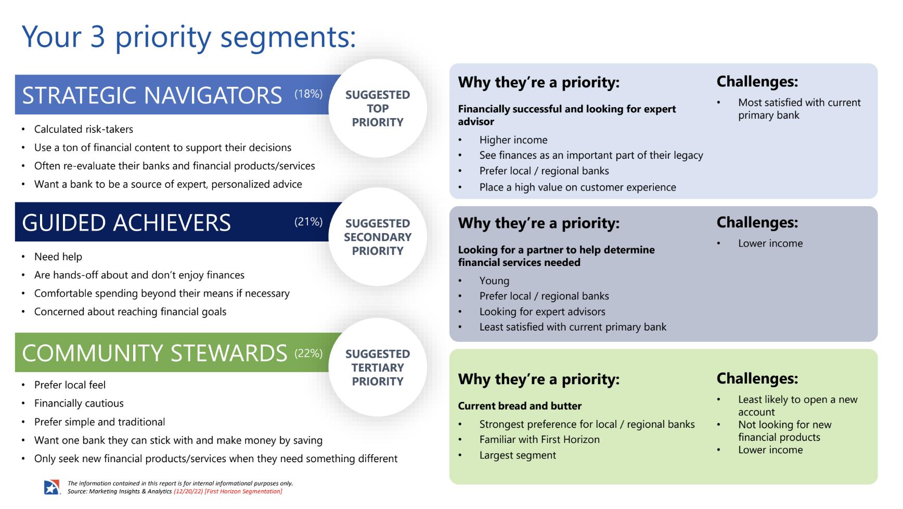

**OOH Media Considerations:**

* Leverage OOH to drive mass awareness in within First Horizon’s invest & scale markets
* Focus on splashy sponsorship, engaging and high-impact executions to grab user attention.
* Interested creative ad executions and new OOH formats to stand out within the local markets
  + Use First Horizon’s “Let’s Find a Way” creative messaging to inspire unique OOH creative executions that go beyond traditional billboards
* Looking for placement with large OOH in high trafficked and prominent areas of each market
* Build frequency to help consumers view First Horizon Bank as a member of the community
* Additional Notes: Stay away from bus shelters; interested in exploring airport opportunities

| **First Horizon Markets** | **Targeting Level** | **Sports Alignments** | **Event Alignments** |
| --- | --- | --- | --- |
| Nashville | DMA | Nashville Predators (NHL)  Tennessee Titans (NFL)  Nashville Sounds (Minor League Baseball)  Nashville SC (MLS) | CMA Fest  Nashville July 4th  The Nashville Show 2024  SCI Convention (Safari Club International)  Nashville RV Show  Nashville St. Paddy's 5k and 1/2 Marathon |
| Triad (Winston-Salem, High Point, and Greensboro) | DMA | Carolina Cobras (Arena Football)  Carolina Thunderbirds (Minor League Hockey)  Greensboro Grasshoppers (Minor League Baseball)  Greensboro Swarm (NBA G League) | Greensboro Fun Fourth Fireworks 2024  The Liberty Showcase Theater Events  The Corner Farmers Market" |
| Triangle (Raleigh, Durham, and Chapel Hill) | DMA | Carolina Hurricanes (NHL)  Duke Basketball & Football  UNC Basketball & Football  Wake Forest BasketBall & Football | IBMA Bluegrass Live! Powered by PNC 2024  Brewgaloo 2024  Got To Be NC Festival  Peak City Pig Fest 2024  Beer, Bourbon & BBQ Festival - Cary  Raley Field Brewfest |
| Charlotte | DMA | Charlotte Hornets (NBA)  Carolina Panthers (NFL)  NCAA Men's Basketball Tournament  Charlotte FC (MLS)  Charlotte Checkers (Minor League Hockey) | Food Lion Taste of Charlotte 2024  Charlotte SHOUT!  Festival in the Park  Charlotte Wine & Food Week |
| Miami | FH Branch Radius Targeting (10 miles) | Miami Heat (NBA)  Miami Dolphins (NFL)  Florida Panthers (NHL)  Formula 1 Miami Grand Prix  NASCAR  Miami Open (Tennis) | South Beach Wine & Food Festival  South Beach Jazz Festival  Calle Ocho Music Festival  Miami Dade CountryFest  Art Basel Miami Beach  Miami Carnival Parade and Concert |
| Orlando | FH Branch Radius Targeting (10 miles) | Orlando Magic (NBA)  Orlando Predators (Arena Football)  NASCAR - Daytona International Speedway | 65th Winter Park Sidewalk Art Festival  Festival Calle Orange  Music Fest Orlando  Central Florida Fair 2024  Spring Fiesta in the Park 2024  Orlando Balloon Festival 2024 |
| Tampa | FH Branch Radius Targeting (10 miles) | Tampa Bay Buccaneers (NFL)  Tampa Bay Lightning (NHL)  Tampa Bay Rays (MLB) | Florida State Fair  Tampa Bay Blues Festival  Tampa Bay Margarita & Music Festival  Tampa Bay Caribbean Carnival 2024  3rd Annual Beer & Burger Festival |

**Flighting:**

* March 4, 2024 to December 31, 2024
* We would like to distribute media volume evenly across each month, but are open to slightly increasing volume around key events and sponsorship alignments with the Invest & Scale markets and slightly decreasing volume in November and December (Holiday season).
* Note that we are planning for the full year now, First Horizon may potentially approve media budgets on a quarterly basis

**Budget:**

* Please find proposal budget levels specified within your RFP email
* Please provide scalable opportunities and a few options so we can customize your plan based on our objectives
* We need to implement monthly spend goals/caps for this campaign due to client billing processes and the extended 12 month flight
  + Consider the monthly budget you are able to clear factoring in the campaign’s audience and DMA targeting parameters.

**Possible Ad Units:**

* HTML5 banners in IAB sizes
* Video :15 & :30 Spots
* Rich Media if you can build for us
* Native images and copy
* :15, :30 Audio Spots
* Custom OOH (if applicable)
* Custom Content (if applicable)

**Considerations:**

In your responses to the RFP, carefully examine the following:

* What strategies, tactics, and audience targeting has been successful on previous First Horizon campaigns and/or with other financial services advertisers?
* How can your campaign optimize to top performing tactics?
* What is truly unique and engaging about your platform?
* How can you uniquely support First Horizon’s positioning?
* Consider campaign measurement and reporting capabilities (i.e. can we implement conversion pixels, can you offer added value brand studies, etc.)
* Sponsorships, custom content opportunities, and first to market opportunities

**Evaluation:**

All RFP responses will ultimately be evaluated on both industry-accepted metrics (such as: target audience composition, ad units, site/network reach & frequency, rates & targeted placements) but ALSO on the innovativeness of the ideas themselves (ad units, targeting, new advertising opportunities) as well as added value.

(*Note: All digital ad-serving will be done via 3rd party ad server, Doubleclick Campaign Manager. The agency is responsible for all ad-serving fees and will be billed on 3rd party delivery, unless otherwise agreed upon.)*

**Deliverables:**

Please include the following key information with your proposal:

* In order to expedite negotiations, please submit your most aggressive rate structure in the initial proposal
* Please include minimums per month or campaign
* Ad specs
* Research on target audience as available
* Screenshots of placements
* Any added value components including Brand Studies
* Contact information for Acct Manager and/or Ad Ops Manager that will be handling our account
* Reporting and 3rd party tracking, tagging, and conversion pixel capabilities

**Please submit all proposals electronically to:**

Ryan Troha: [rtroha@mindgruve.com](mailto:rtroha@mindgruve.com)

Emily Borgeson: [eborgeson@mindgruve.com](mailto:eborgeson@mindgruve.com)

Danielle Boccio: [dboccio@mindgruve.com](mailto:dboccio@mindgruve.com)

Nicola Brennan [nbrennan@mindgruve.com](mailto:nbrennan@mindgruve.com)

Proposal is due Wednesday, November 15, 2023**.** If you have any questions or need further clarification, please feel free to contact us. We look forward to receiving your proposal and potentially working with you on this effort!

Thank you!

Mindgruve Media Team